Arrival and Dismissal Locations

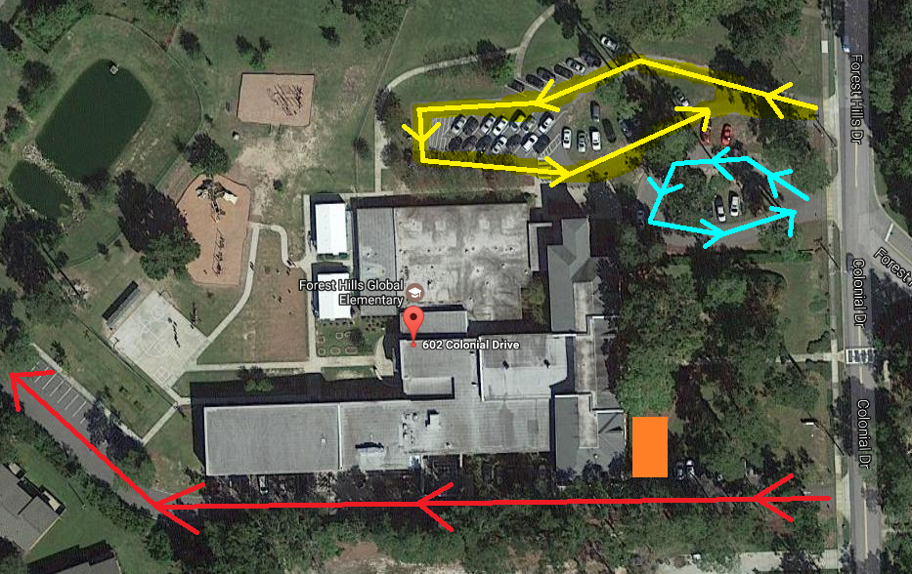

Yellow: Student Drop off, Pickup & Visitor Parking
Blue: Vans
Red: Bus Lane
Orange: Walker Pick Up Area

