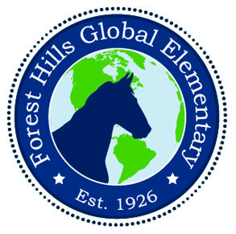
MUSTANG MAIL: NOVEMBER 2019

Week #1
November 4 - 8
- November 7 - Report Cards will be sent home
- November 8 - Quarter 1 Golden Globe Awards - Join us as we celebrate student achievement at our quarterly awards assembly! 2 -3 will begin at 8:15, K - 1 will begin at 9:15 and 4 - 5 will begin at 10:15.
- November 8 - Veterans Day Lunch - Welcome Veterans! Join your child/grandchild during their lunch time in the cafeteria.

Week #2
November 11 - 15
- November 11 - 15 - Geography Awareness Week
- November 11 - Veterans Day Holiday - School Closed for all students and staff.
- November 13 - School Make-up Picture Day

Week #3
November 18 - 22
- November 19 - Family Coding Night - 5:00 - 7:00 - Join us for a fun filled night of dinner and creating with your child while coding! Plus, get updated by our PTA!!!
- November 20 - 3:30 - 5:00 SIT Meeting - media center - Parents, Teachers: send Compliments or Concerns to SIT Chairs holly.minnear@nhcs.net / elizabeth.lovoy@nhcs.net or your child’s teacher.
- November 22 - PBIS Club Time - 12:30 - 2:00 - We will be having our 3rd PBIS Club Time to celebrate the behavioral success of our students!! Students with less than 3 classroom referrals and no office referrals will have the privilege to choose their club of interest.

Week #4
November 25 - 29
- November 26 - Eat and Read with a Grandie - Grandparents are invited to join their grandchildren for a delicious Thanksgiving lunch and then an opportunity to read with them!
- November 27, 28, 29 - Thanksgiving Holidays - School Closed for all students and staff.

Coming in December ...
Dec. 9 - 13 - Hour of Code
Dec. 9 - Science Fair Projects are due
Dec. 16 -19 - FHGES Book Fair
Dec. 17 - Winter Family Fun Night
Dec. 20 - Classroom Winter Celebrations/ Half Day for Students
Dec. 23 - Jan 1 - Winter Break - No school for students or staff
Jan. 2 - Students return / New Year Celebrations around the world

Forest Hills will develop globally minded
leaders by fostering respect, safety, collaboration
and high academic standards for all.

Explore the World. Be the Change

